3.45: a) The 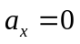 and 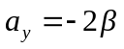, so the velocity and the acceleration will be perpendicular only when 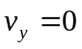, which occurs at 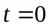.
b) The speed is 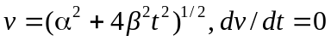 at . (See part d below.)
c) r and v are perpendicular when their dot product is 0: . Solve this for t: 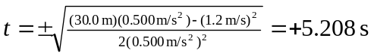, and 0 s, at which times the student is at (6.25 m, 1.44 m) and (0 m, 15.0 m), respectively.
d) At 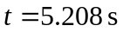, the student is 6.41 m from the origin, at an angle of 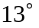 from the x-axis. A plot of 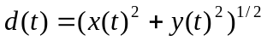 shows the minimum distance of 6.41 m at 5.208 s:

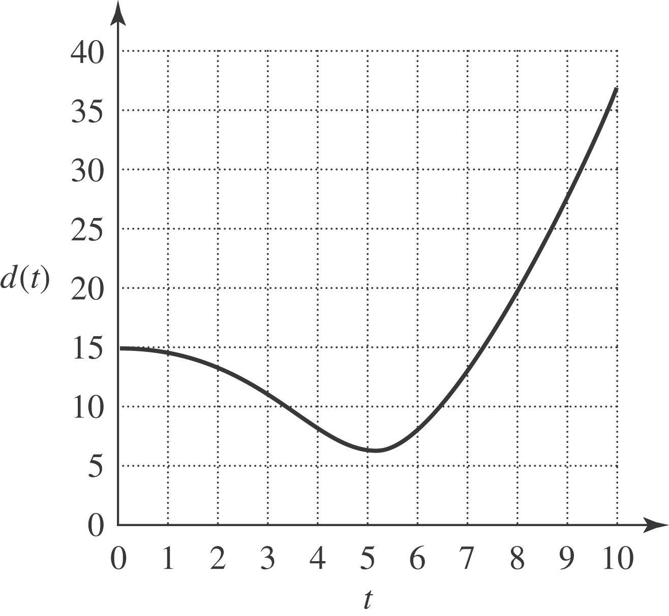
e) In the x - y plane the student’s path is:

